Order Of Service

Singing: Psalm 62—CW page 88

Reading: Psalm 148

Opening Hymn: TLH 648

Reading: I Corinthians 3:1-9

Request Hymn: CW Supplement 754

Reading: Matthew 26:6-13

Sermon Hymn: TLH 375

Sermon Text: Luke 8:22-25

Wind And Water

Prayer

The Apostles’ Creed, TLH page 12

Holy Communion

The Lord's Prayer

The Blessing

Closing Hymn: TLH 382

* * * * * * * * * * *

Bible Study: Lambs: Musk Ox
Sheep: Proverbs 31:1-5
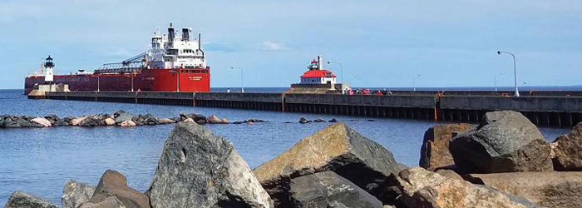

Entering Harbor, Duluth

Water
Of
Life

18 July 2021

W A T E R O F L I F E

Independent Christian Church—Conservative Lutheran Doctrine

Worship Service: 9:30 a.m. Bible Study: 10:45 a.m.

Larry Cooper, Pastor E-Mail address:
111 N. Ridge Road lcooper@wateroflife.cc
Coon Valley, WI 54623 Web Site:
www.wateroflife.cc

* * * * * * * * * * * * * * * * * * * * * * * * * * *

Sermon Text: Luke 8:22-25

Wind And Water

* * * * * * * * * * * * * * * * * * * * * * * * * * *

Luke 8:22 Now it came to pass on a certain day, that he went into a ship with his disciples: and he said unto them, Let us go over unto the other side of the lake. And they launched forth.
:23 But as they sailed he fell asleep: and there came down a storm of wind on the lake; and they were filled with water, and were in jeopardy.
:24 And they came to him, and awoke him, saying, Master, master, we perish. Then he arose, and rebuked the wind and the raging of the water: and they ceased, and there was a calm.
:25 And he said unto them, Where is your faith? And they being afraid wondered, saying one to another, What manner of man is this! for he commandeth even the winds and water, and they obey him.

